**Course Methods Year 12 test one 2022**

Student name: ________________ Teacher name: ________________

**Task type: Response**

**Time allowed for this task: _____40______ mins**

**Number of questions: ____8_______**

**Materials required: No calculators nor classpads allowed**

Standard items: Pens (blue/black preferred), pencils (including coloured), sharpener, correction fluid/tape, eraser, ruler, highlighters

Special items: Drawing instruments, templates, notes on one unfolded sheet of   
A4 paper.

**Marks available: ___40___ marks**

**Task weighting: __10__%**

**Formula sheet provided: Yes**

**Note: All part questions worth more than 2 marks require working to obtain full marks.**

Q1 (3, 4 & 3 = 10 marks)

Differentiate the following:

1. 

|  |
| --- |
| **Solution** |
|  |
| **Specific behaviours** |
| P correct power  P uses factor of 5  P uses factor of 3  (no need to simplify) |

1.  and simplify

|  |
| --- |
| **Solution** |
|  |
| **Specific behaviours** |
| P uses product rule  P uses chain rule for bracket term  P obtains a correct expression  P shows a fully simplified expression |

1.  (do not simplify)

|  |
| --- |
| **Solution** |
|  |
| **Specific behaviours** |
| P uses quotient rule  P correct denominator  P correct numerator |

Q2 (4 marks)

Determine the equation of the tangent to  at 

|  |
| --- |
| **Solution** |
|  |
| **Specific behaviours** |
| P uses product rule  P determines gradient  P sets up a constant and equation to solve  P states tangent line |

Q3 (5 marks)

Determine the coordinates of the stationary points and their nature for . Justify.

|  |
| --- |
| **Solution** |
|  |
| **Specific behaviours** |
| P determines first derivative  P equates derivative to zero  P solves for x values of both stationary pts  P uses a derivative test and shows values to determine nature  P determines y values of stationary pts |

Q4 (3 marks)

The displacement of a body from an origin O, at time  seconds, is  metres where



Determine the velocity and the displacement of the body when the acceleration is zero.

|  |
| --- |
| **Solution** |
|  |
| **Specific behaviours** |
| P differentiates to determine velocity and acceleration  P equates acceleration to zero and solves for t  P states velocity and displacement for this time |

Q5 (4 marks)

Consider the function  which is graphed below.

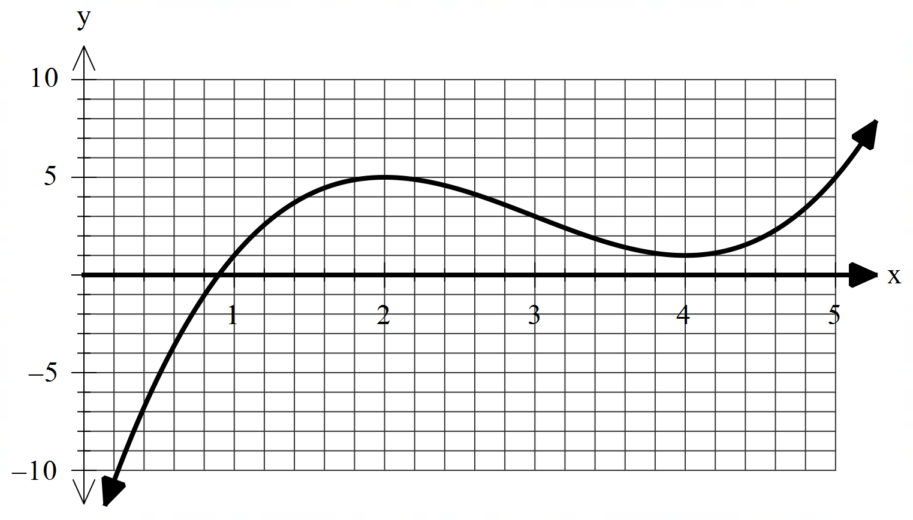

On the **axes below**, sketch the gradient function  indicating on your sketch the location of any stationary points and any inflection points. (labelled)

|  |
| --- |
| **Solution** |
|  |
| **Specific behaviours** |
| P correct shape being concave up with a min turning pt (location may differ)  P labels local minimum (accept min)  P labels inflection pt  P labels local max (accept max)  Note: No follow through if sketch is wrong as original function given & do not accept turning pt) |

Q6 (2 & 3 = 5 marks)

Consider the function  where .

1. Using the increments formula (small change) determine an approximate value for  and express this as an approximate percentage change again using the increments formula.

|  |
| --- |
| **Solution** |
|  |
| **Specific behaviours** |
| P uses increments formula  P determines approx. g(2.1) |

1. The volume of a sphere of radius  metres is given by . Using the increments formula determine the approximate percentage change in volume for a 3% change in the radius.

|  |
| --- |
| **Solution** |
|  |
| **Specific behaviours** |
| P sets up an expression for percentage change in volume  P simplifies expression  Psubs % change for r to give approx. % change in V |

Q7 (4 marks)

Let  equal the number of hectares that a farmer will use to grow corn one season. The amount of corn to be harvested per hectare is given by  kg for  . **Using calculus** determine the number of hectares that should be used to maximise the amount of corn produced.

|  |
| --- |
| **Solution** |
|  |
| **Specific behaviours** |
| P determines expression for total amount of corn  P differentiates and equates to zero  P solves for A (no units required)  P shows using a derivative test that this is a local max |

Q8 (5 marks)

Let the cost, $, to make  items in a factory be given by  dollars. Using calculus show that the minimum **average cost** per item is equal to the marginal cost at this number of items.

|  |
| --- |
| **Solution** |
|  |
| **Specific behaviours** |
| P determines exp for average and differentiates  P equates derivative to zero and solves for x  P shows with derivative test that local min  P shows marginal cost formula  Pshows both equal at required x value |